

BTIS 3023

PRACTICAL PROJECT 1

Stage 2 (Revised Version)

Topic:

Inventory Management System

Name | : | Lim Jing Xiang
Student ID | : | B130037C
Batch | : | BSE13-C2
Supervisor | : | Mr. So Yong Quay
Submit Date | : | 10th June 2014.

Department of Computer Science

Faculty of Engineering and Information Technology
Table of Contents

1.0 DFD diagram 3

1.1 Context level 3

1.2 DFD Diagram 0 4

1.3 DFD Diagram 1 5

2.0 ER diagram 10

3.0 Class diagram 11

4.0 Use case diagram 12

4.1 Customer system 12

4.2 Inventory system 13

4.3 Payment system 14

4.4 Report System 14

4.5 Purchase order system 15

4.6 Sales order system 16

5.0 Use case description 17

5.1 Customer system 17

5.2 Inventory System 24

5.3 Payment System 30

5.4 Report System 32

5.5 Purchase order system 36

5.6 Sales order system 40

6.0 Activity diagram 45

6.1 Customer system 45

6.2 Inventory System 46

6.3 Payment System 47

6.4 Report System 48

6.5 Purchase order system 49

6.6 Sales order system 50

7.0 Sequences diagram 51

7.1 Customer system 51

7.2 Inventory System 53

7.3 Payment System 54

7.4 Report System 56

7.5 Purchase order system 57

7.6 Sales order system 59

Page | 2
1.0 DFD diagram

1.1 Context level
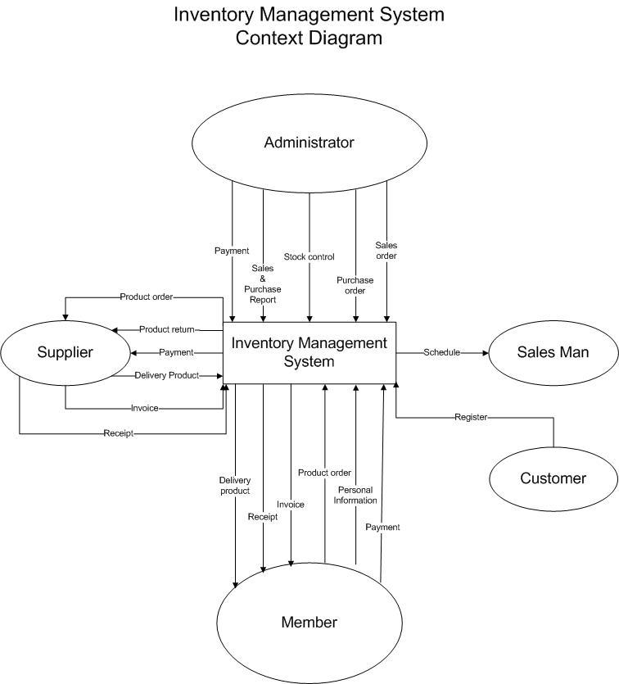

Page | 3
1.2 DFD Diagram 0
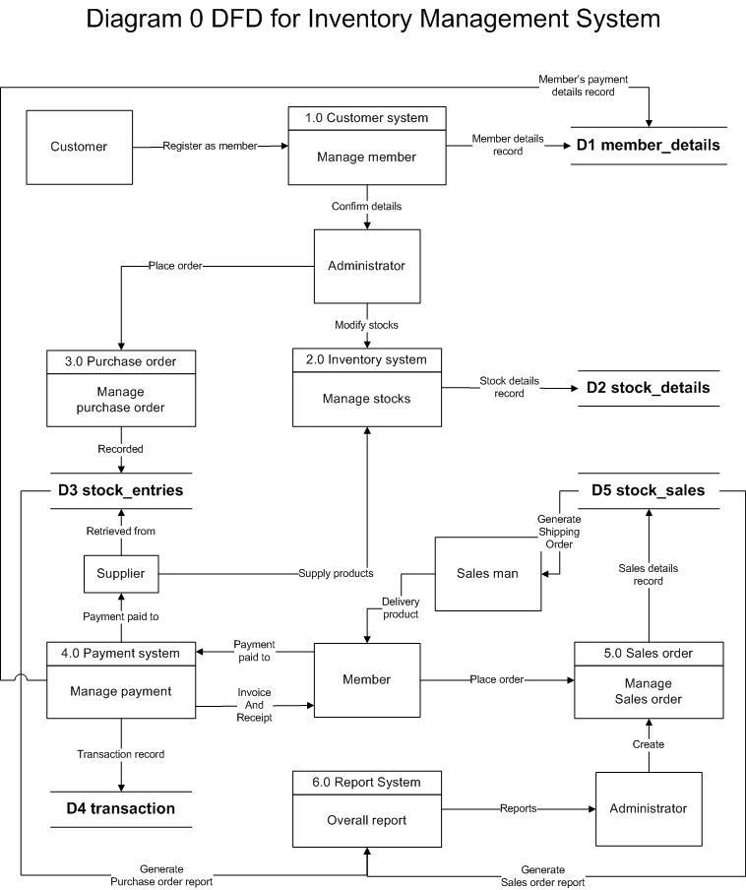

Page | 4
1.3 DFD Diagram 1

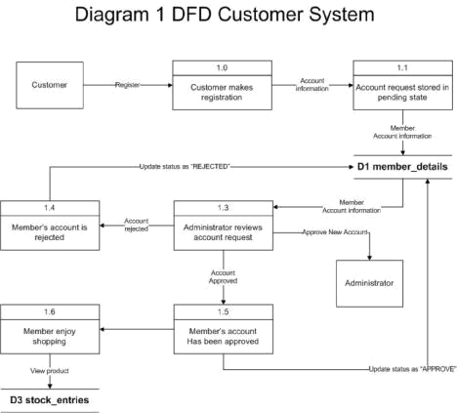

Page | 5
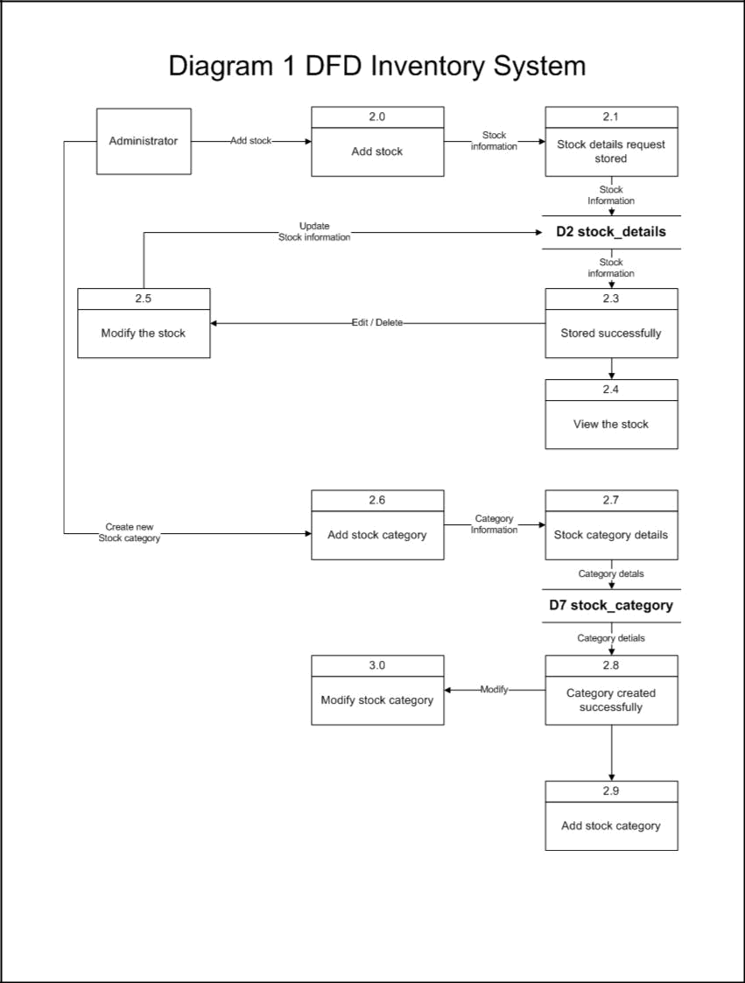

Page | 6
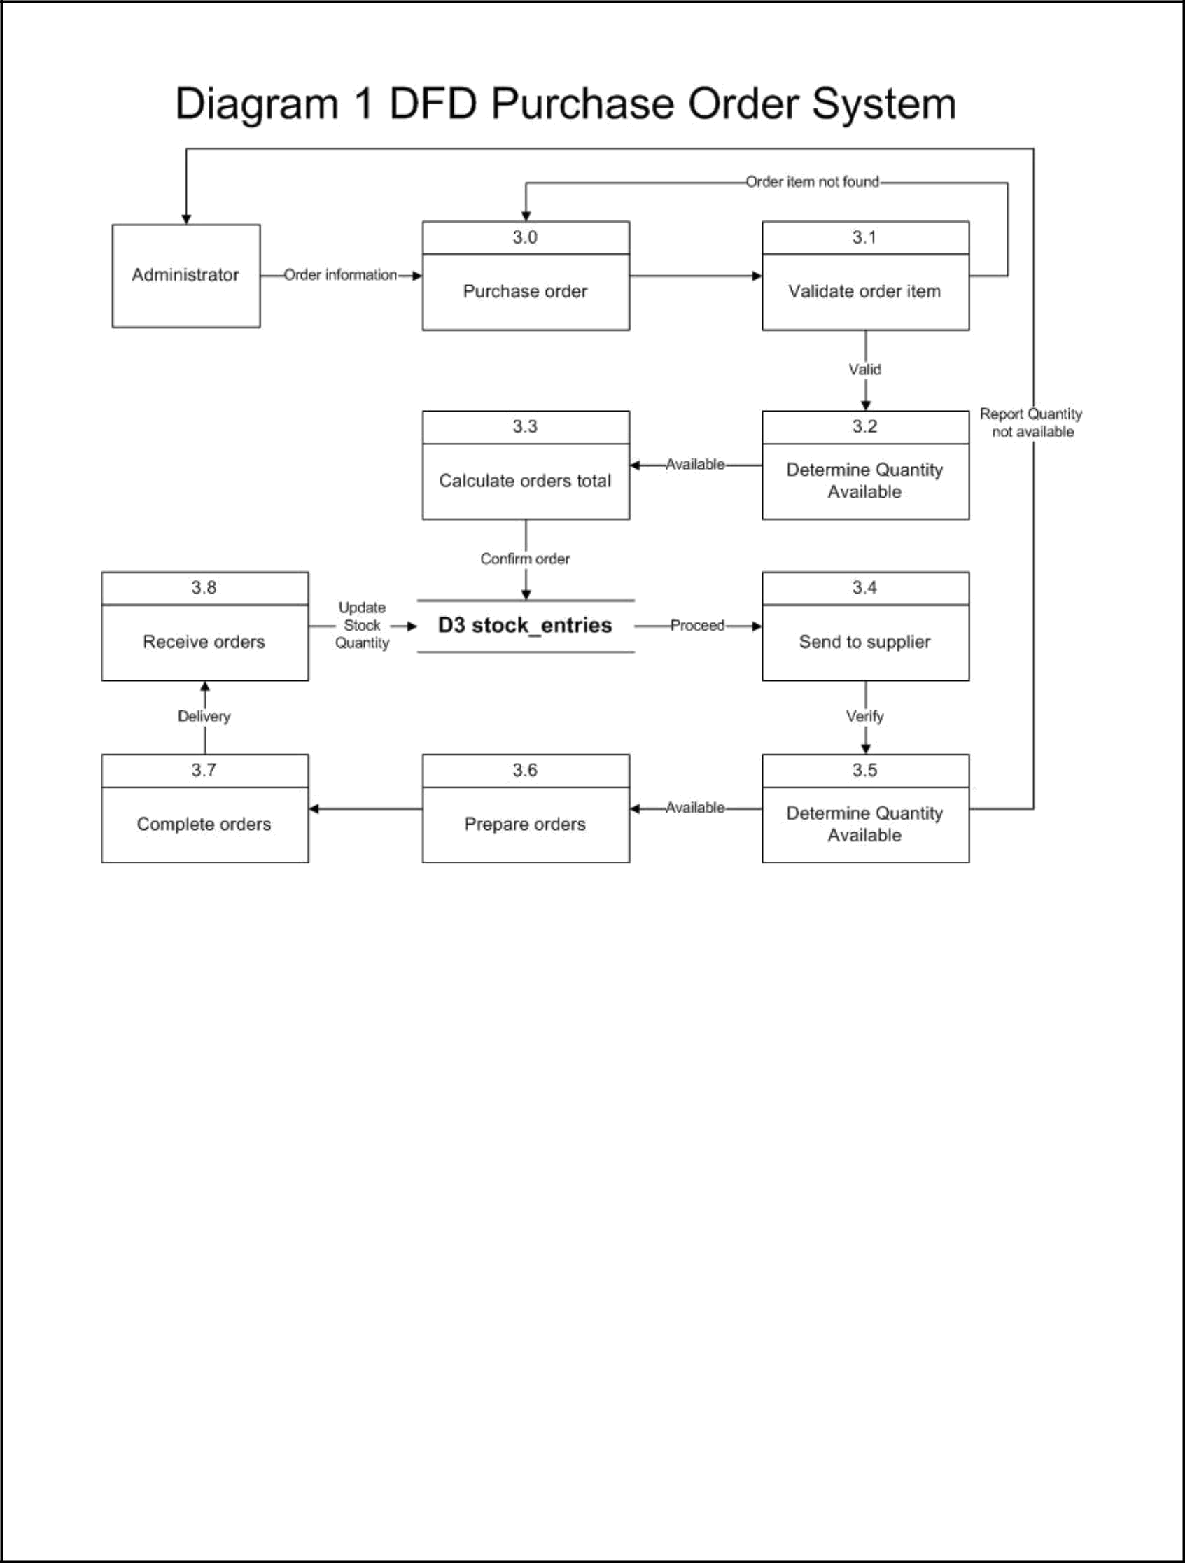

Page | 7
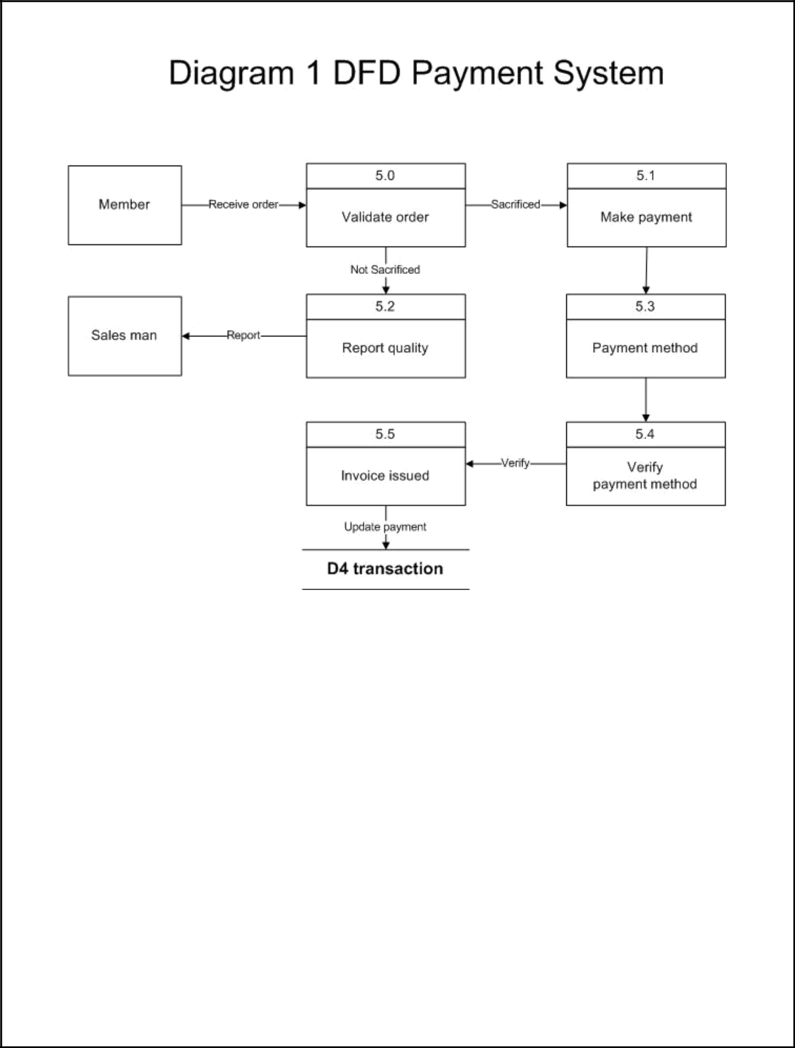

Page | 8
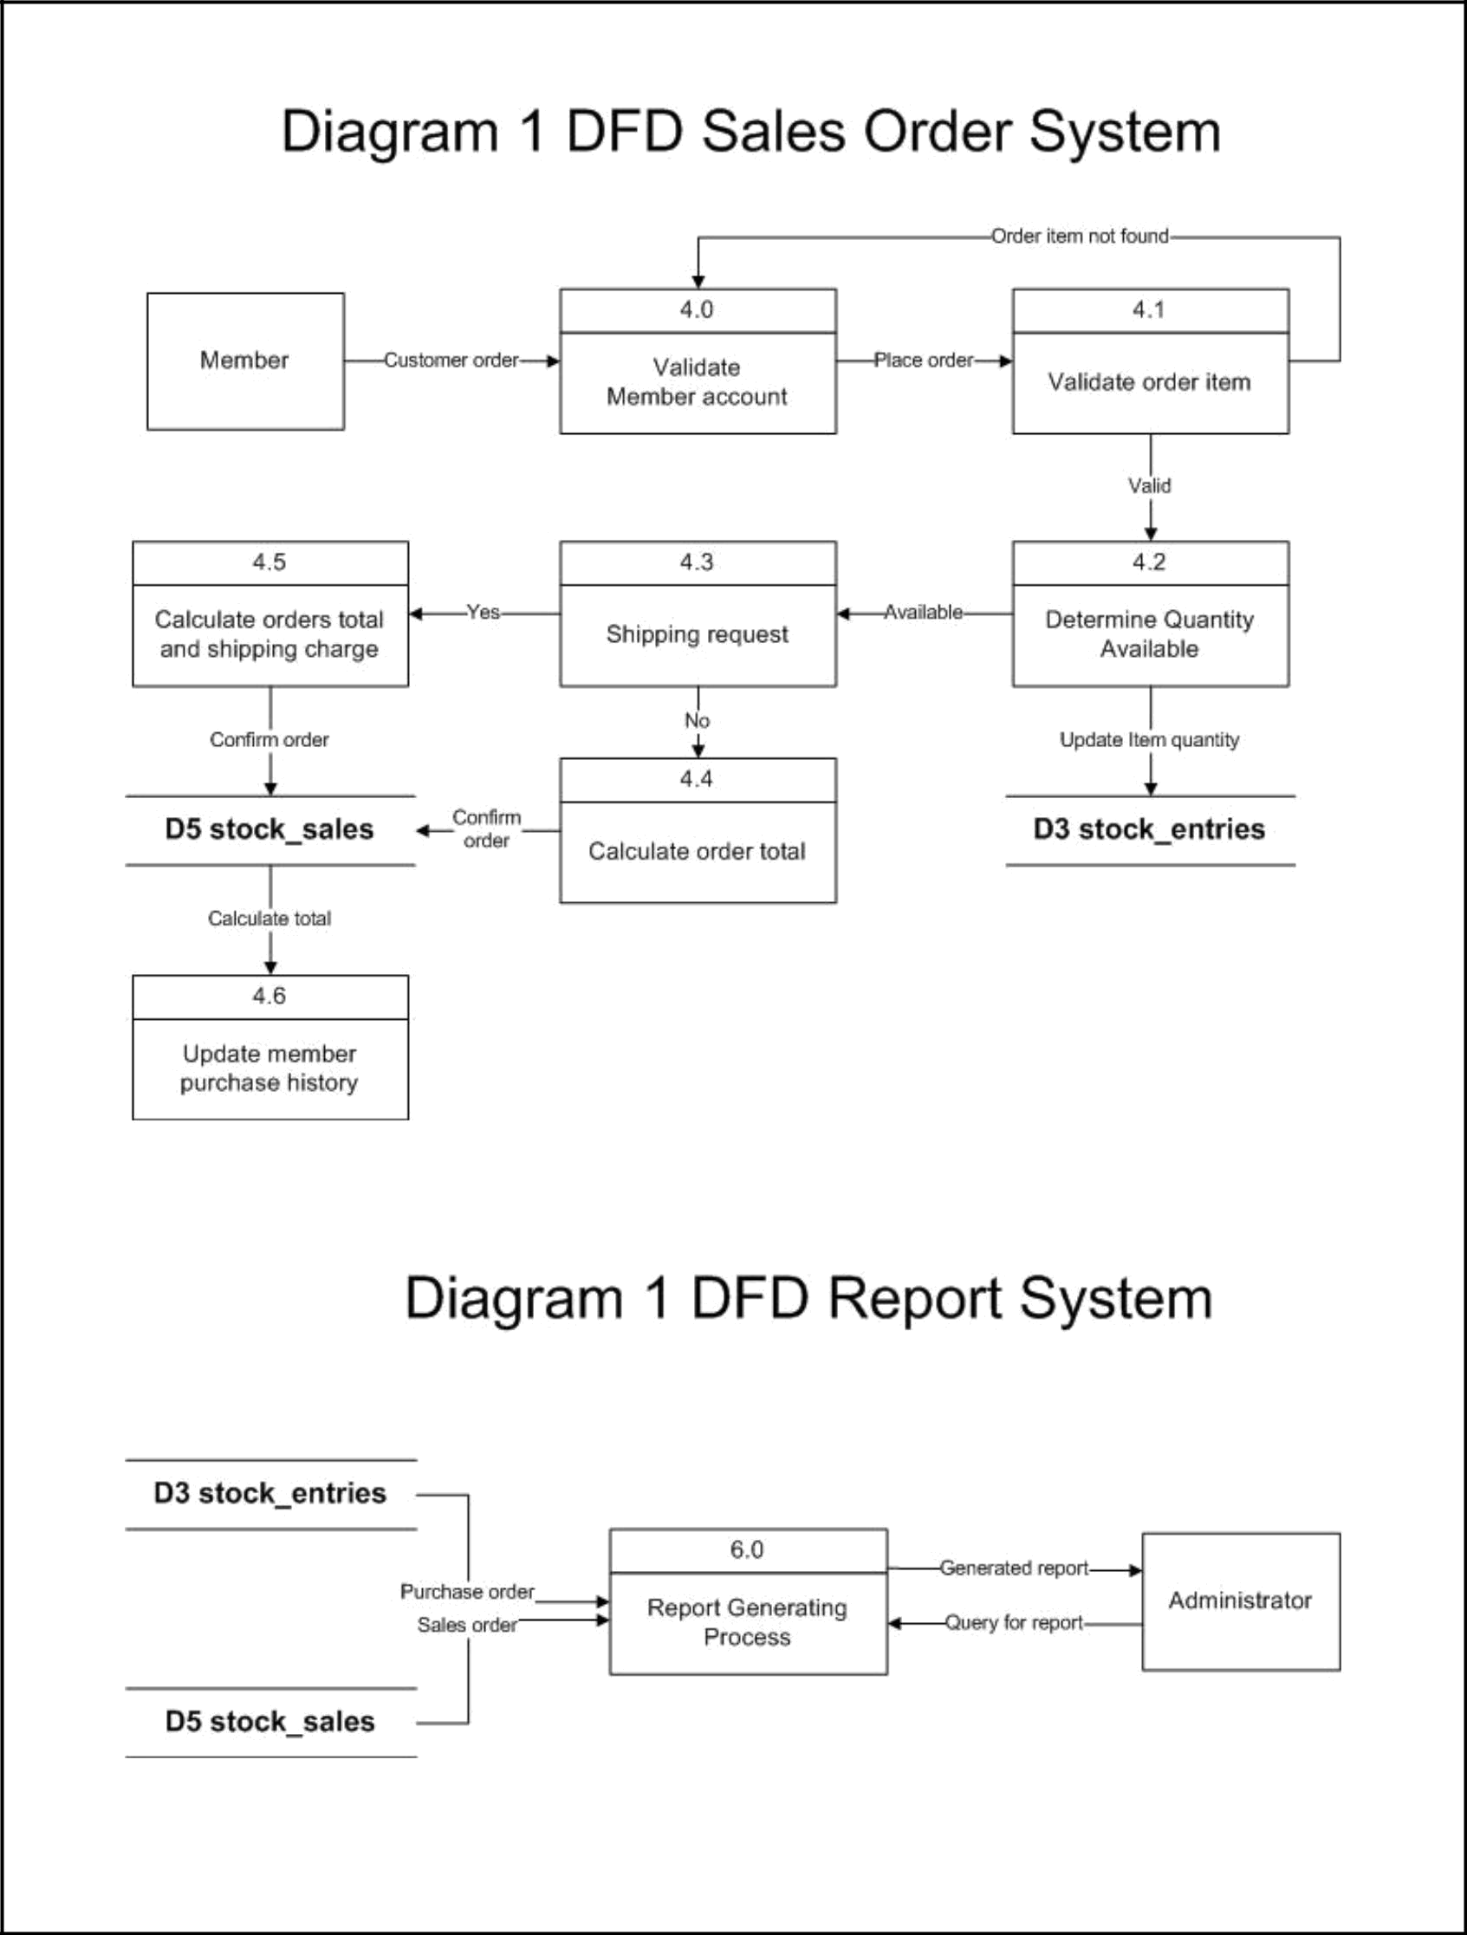

Page | 9
2.0 ER diagram

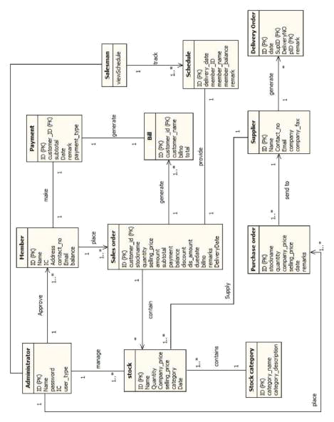

Page | 10
3.0 Class diagram

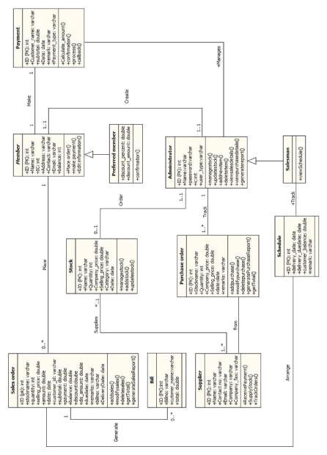

Page | 11
4.0 Use case diagram

4.1 Customer system

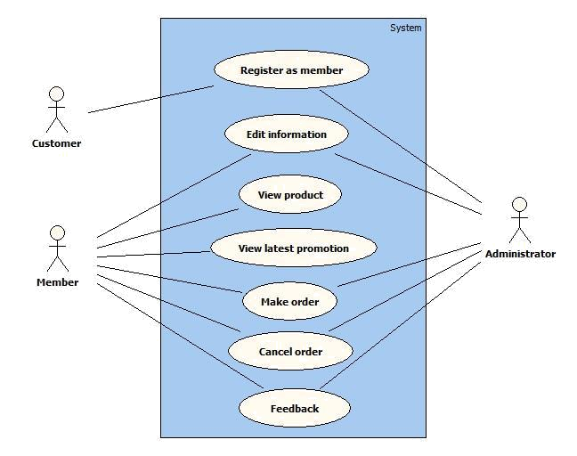

Page | 12
4.2 Inventory system

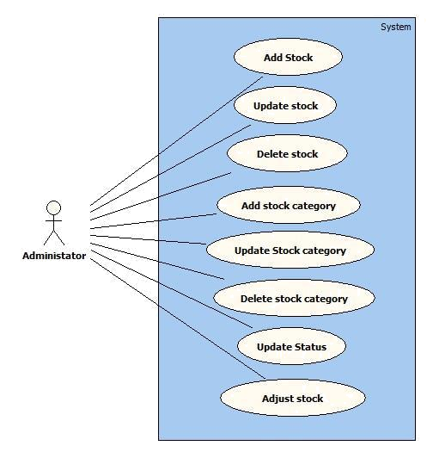

Page | 13
4.3 Payment system

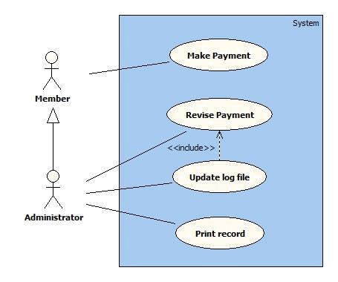

4.4 Report System

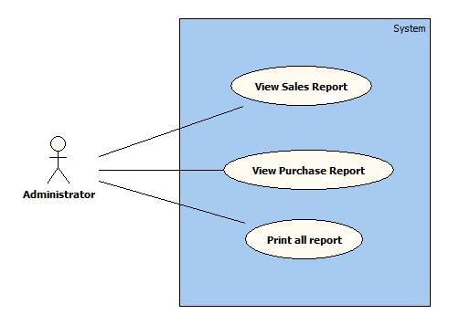

Page | 14
4.5 Purchase order system

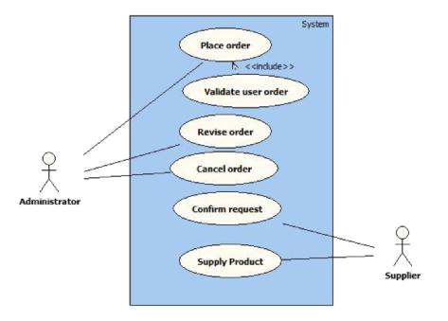

Page | 15
4.6 Sales order system

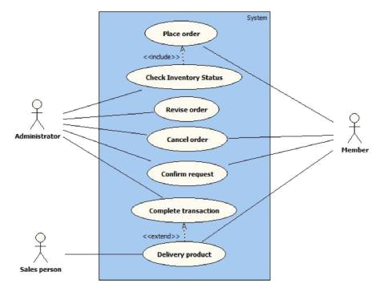

Page | 16
5.0 Use case description

5.1 Customer system

Use case: Register as member (Customer system)

Overview: This case describes how the customer register as a member.

Pre-conditions: -

Post conditions:

- Successful condition
  - Χυστομερ ηασ ρεγιστερεδ ασ α μεμβερ ανδ μεμβερ αχχουντ ισ χρεατεδ
 | Event |  | Response
1 | Customer enter to the webpage | • | Different available alternative displayed.
 | system.
2 | Select login in webpage. | • | Different available alternative displayed.
3 | Select sign up. | • | Prompt Sign-up UI.
4 | Enter all the required information. | • | Perform information validation.
5 | Customer register successfully. | • | Member account is created.
Extensions
1 | Invalid webpage. | • Message “The requested URL was not
 |  |  | found on this server. Please try again”
 |  |  | displayed.
1 | Unable to display webpage | • Message “Web page is under construction.
 | content. |  | Please try again later.”
4 | Invalid information. | • Display warning message to reject the
 |  |  | details.
 |  | • Request to re-enter the details.

Page | 17
Use case: Edit information (Customer system)

Overview: This case describes how the member edit personal information.

Pre-conditions:

1. The login user must be member.

Post conditions:

- Successful condition

  - Μεμβερ ηασ υπδατε τηειρ περσοναλ ινφορματιον συχχεσσφυλλψ.
 | Event |  | Response
1 | Member login to the webpage. | • | Perform user account validation.
 |  | • Different available alternative displayed.
2 | Member select personal | • | Different available alternative displayed.
 | information.
3 | Member select update personal | -
 | information.
4 | Edit the personal information. | • | Perform information validation.
5 | Member has updated the | • | Updated successfully.
 | information successfully. | • | Return to the webpage.
Extensions
1 | Invalid user account. | • | Message “Invalid Account/Wrong
 |  |  | password – please try again” displayed.
4 | Invalid information. | • Prompt alert box “Invalid information –
 |  |  | please try again.”
 |  | • | Resume step 4.

Page | 18
Use case: View product (Customer system)

Overview: This case describes how the member view the product.

Pre-conditions:

1. The login user must be member.

Post conditions:

- Successful condition

  - Μεμβερ ηασ ϖιεω τηε προδυχτ συχχεσσφυλλψ.
 | Event |  | Response
1 | Member login to the webpage. | • | Perform user account validation.
 |  | • Different available alternative displayed.
2 | Member select view product. | • | Different available alternative displayed.
3 | Member has view product | -
 | successfully.
Extensions
1 | Invalid user account. | • | Message “Invalid Account/Wrong
 |  |  | password – please try again” displayed.
2 | Invalid request. | • | Close session.
 |  | • | Resume Homepage.

Page | 19
Use case: View latest promotion (Customer system)

Overview: This case describes how the member view the latest promotion.

Pre-conditions:

- The login user must be member. Post conditions:

- Successful condition

  - Μεμβερ ηασ ϖιεω τηε λατεστ προμοτιον συχχεσσφυλλψ.
 | Event |  | Response
1 | Member login to the webpage. | • | Perform user account validation.
 |  | • Different available alternative displayed.
2 | Member select latest promotion. | • | Different available alternative displayed.
3 | Member has view product | -
 | successfully.
Extensions
1 | Invalid user account. | • | Message “Invalid Account/Wrong
 |  |  | password – please try again” displayed.
2 | Invalid request. | • | Close session.
 |  | • | Resume Homepage.

Page | 20
Use case: Place order (Customer system)

Overview: This case describes how the member place an order.

Pre-conditions:

1. The login user must be member.

Post conditions:

1. Successful condition

    - Member has place order successfully.
- Failure condition

  - Τηε λογσ ηαϖε βεεν υπδατεδ αχχορδινγλψ.
 | Event |  | Response
1 | Member login to the webpage. | • | Perform user account validation.
 |  | • | Different available alternative
 |  |  | displayed.
2 | Member select product from website | • | Different available alternative
 | in navigation bar. |  | displayed.
3 | Member click on place order button. | • | Prompt place order UI.
4 | Enter all the required information. | • | Perform information validation.
5 | Order created successfully. | • | New Sales order is created
 |  |  | successfully.
6 | Member print the sales order. | • | Perform printer validation.
 |  | • Return to sales order system.
Extensions
1 | Invalid user account. | • | Message “Invalid Account – please try
 |  |  | again” displayed.
4 | Invalid details. | • | Display warning message to reject the
 |  |  | details.
 |  | • Request to re-enter the details.
6 | Unable connect to the printer. | • | Prompt alert message “Printer is
 |  |  | offline! Please check!”
 |  | • | Resume step 5.

Page | 21
Use case: Cancel order (Sales order system)

Overview: This case describes how the member cancel an order.

Pre-conditions:

1. The login user must be member.

Post conditions:

- Successful condition

  - Member has cancel the stock successfully.

 | Event | Response
1 | Member login to the webpage. | • Perform user account validation.
 |  | • Different available alternative displayed.
2 | Member select product history. | • Different available alternative displayed.
3 | Member select an order. | -
4 | Cancel the order. | • Perform confirm validation.

- Member cancel the order successfully. • The order is cancel successfully.
  - Return to Sales order system.

Extensions

1 | Invalid user account. | • Message “Invalid Account – please try
 |  | again” displayed.
4 | Invalid request. | • Close session.
 |  | • Resume step 3.

Page | 22
Use case: Feedback (Customer system)

Overview: This case describes how the member provide feedback.

Pre-conditions:

- The login user must be member. Post conditions:

- Successful condition
  - Member has provide feedback successfully.

 | Event |  | Response
1 | Member login to the webpage. | • | Perform user account validation.
 |  | • Different available alternative displayed.
2 | Member select support. | • | Different available alternative displayed.
3 | Select feedback. | -
4 | Enter all the required information. | • | Perform information validation.
5 | Submit feedback. | • | Perform feedback UI.
6 | Print out feedback. | • | Perform printer validation.
7 | Member provide feedback | • | Return to Homepage.
 | successfully.
Extensions
1 | Invalid user account. | • Message “Invalid Account – please try
 |  |  | again” displayed.
4 | Invalid input. | • Display warning message to reject the
 |  |  | details.
 |  | • Request to re-enter the details.
6 | Unable connect to the printer. | • Prompt alert message “Printer is offline!
 |  |  | Please check!”
 |  | • | Resume step 5.

Page | 23
5.2 Inventory System

Use case: Add Stock (Inventory system)

Overview: This case describes how the administrator create new stock.

Pre-conditions:

1. The login user must be administrator.

Post conditions:

- Successful condition

  - Administrator has purchased the goods successfully.
- Failure condition
- Τηε λογσ ηαϖε βεεν υπδατεδ αχχορδινγλψ.
 | Event |  | Response
1 | Administrator login to the system. | • | Perform user account validation.
 |  | • | Different available alternative
 |  |  | displayed.
2 | Administrator select Inventory system. | • | Different available alternative
 |  |  | displayed.
3 | Administrator select add new record. | • | Prompt add new record UI.
4 | Administrator enter all the required | • | Perform details validation.
 | information.
5 | Administrator create the record | • | New stock is created successfully.
 | successfully. | • | Return to Inventory system.
Extensions
1 | Invalid user account. | • | Message “Invalid Account – please try
 |  |  | again” displayed.
4 | Invalid details. | • | Display warning message to reject the
 |  |  | details entered by administrator.
 |  | • Request to re-enter the details.

Page | 24
Use case: Update Stock (Inventory system)

Overview: This case describes how the administrator update stock.

Pre-conditions:

1. The login user must be administrator.

Post conditions:

- Successful condition

  - Αδμινιστρατορ ηασ υπδατεδ τηε στοχκ συχχεσσφυλλψ.
 | Event |  | Response
1 | Administrator login to the system. | • | Perform user account validation.
 |  | • | Different available alternative
 |  |  | displayed.
2 | Administrator select Inventory system. | • | Different available alternative
 |  |  | displayed.
3 | Select view stock. | -
4 | Select a stock. | -
5 | Administrator edit the stock details. | • | Perform details validation.
6 | Administrator update the stock record | • The record is updated successfully.
 | successfully. | • | Return to view stock category.
Extensions
1 | Invalid user account. | • Message “Invalid Account – please
 |  |  | try again” displayed.
5 | Invalid details. | • | Prompt alert box “Invalid
 |  |  | information – please try again.”
 |  | • Request to re-enter the details.
6 | The record is not created successfully. | • Message “Unable to update this
 |  |  | result – please try again”.
 |  | • | Resume step 3.

Page | 25
Use case: Add Stock Category (Inventory system)

Overview: This case describes how the administrator add new stock category.

Pre-conditions:

- The login user must be administrator. Post conditions:

- Successful condition
  - Αδμινιστρατορ ηασ χρεατε α νεω χατεγορψ συχχεσσφυλλψ.
 | Event |  | Response
1 | Administrator login to the system. | • | Perform user account validation.
 |  | • Different available alternative displayed.
2 | Administrator select Inventory | • | Different available alternative displayed.
 | system.
3 | Select add stock category. | -
4 | Administrator enter all the | • | Perform details validation.
 | required information.
5 | Administrator create the record | • The record is stored successfully.
 | successfully. | • | Return to view stock category.
Extensions
1 | Invalid user account. | • Message “Invalid Account – please try
 |  |  | again” displayed.
4 | Invalid details. | • Prompt alert box “Invalid information –
 |  |  | please try again.”
 |  | • Request to re-enter the details.
5 | The record is not created | • | Message “Unable to create this result –
 | successfully. |  | please try again”.
 |  | • End with a failure condition.
 |  | • | Resume step 3

Page | 26
Use case: Update Stock Category (Inventory system)

Overview: This case describes how the administrator update stock category.

Pre-conditions:

- The login user must be administrator. Post conditions:

- Successful condition
  - Αδμινιστρατορ ηασ υπδατεδ στοχκ χατεγορψ συχχεσσφυλλψ.
 | Event |  | Response
1 | Administrator login to the system. | • | Perform user account validation.
 |  | • | Different available alternative
 |  |  | displayed.
2 | Administrator select Inventory | • | Different available alternative
 | system. |  | displayed.
3 | Select view stock category. | -
4 | Select a category | -
5 | Edit the category details. | • | Verify all the details.
6 | Save changes. | • The record is created successfully.
 |  | • | Return to view stock category.
Extensions
1 | Invalid user account. | • Message “Invalid Account – please try
 |  |  | again” displayed.
5 | Invalid details. | • Prompt alert box “Invalid information –
 |  |  | please try again.”
 |  | • Request to re-enter the details.
6 | The record is not created successfully. | • Message “Unable to create this result –
 |  |  | please try again”.
 |  | • End with a failure condition.
 |  | • | Resume step 3

Page | 27
Use case: Delete Stock Category (Inventory system)

Overview: This case describes how the administrator delete stock category.

Pre-conditions:

1. The login user must be administrator.

Post conditions:

- Successful condition

  - Administrator has deleted the stock category successfully.
  - Τηε λογσ ηαϖε βεεν υπδατεδ αχχορδινγλψ.
 | Event |  | Response
1 | Administrator login to the system. | • | Perform user account validation.
 |  | • | Different available alternative
 |  |  | displayed.
2 | Administrator select Inventory system. | • | Different available alternative
 |  |  | displayed.
3 | Select add stock category. | -
4 | Select view stock category | -
5 | Select clicks delete button. | • | Prompt confirmation box “Do you
 |  |  | want to delete this record?”
6 | Administrator delete the record | • | The record is deleted.
 | successfully. | • | The logs have been update.
 |  | • | Resume step 4.
Extensions
1 | Invalid user account. | • | Message “Invalid Account – please try
 |  |  | again” displayed.
5 | Invalid request. | • | Prompt alert box “Invalid request –
 |  |  | please try again.”
 |  | • | Resume step 4.

Page | 28
Use case: Adjust stock (Inventory system)

Overview: This case describes how the administrator adjust the stock quantity.

Pre-conditions:

1. The login user must be administrator.

Post conditions:

- Successful condition

  - Αδμινιστρατορ ηασ αδϕυστ τηε στοχκ συχχεσσφυλλψ.
 | Event |  | Response
1 | Administrator login to the system. | • | Perform user account validation.
 |  | • | Different available alternative
 |  |  | displayed.
2 | Administrator select Inventory | • | Different available alternative
 | system. |  | displayed.
3 | Select view stock. | -
4 | Select adjust stock quantity | -
5 | Administrator adjust the stock. | • | Perform checking.
5 | Adjust the stock successfully. | • The record is stored successfully.
 |  | • | Return to view stock category.
Extensions
1 | Invalid user account. | • Message “Invalid Account – please try
 |  |  | again” displayed.
5 | Insufficient stock quantity. | • Prompt warning message “Number of
 |  |  | input is out of the range. Please try
 |  |  | again.”
 |  | • Request to re-enter adjust stock
 |  |  | quantity.

Page | 29
5.3 Payment System

Use case: Make payment (Payment system)

Overview: This case describes how the member make payment.

Pre-conditions: Administrator login to the system.

Post conditions:

- Successful condition

  - Μεμβερ ηασ μακε παψμεντ συχχεσσφυλλψ.
 | Event |  | Response
1 | Administrator select Payment system. | • | Alternative displayed.
2 | Administrator select add payment. | • | Prompt payment UI.
3 | Enter new payment. | • | Verify member name, IC number.
 |  | • | Payment accepted.
 |  | • | Update database.
4 | Print payment record. | • | Perform printer validation.
5 | Member has made payment | • | Return to Payment system.
 | successfully.
Extensions
3 | Insufficient amount | • | Display message to reject the amount.
 |  | • Request to re-enter the amount.
4 | Unable connect to the printer. | • | Prompt alert message “Printer is offline!
 |  |  | Please check!”
 |  | • | Resume step 5.

Page | 30
Use case: Revise payment (Payment system)

Overview: This case describes how the member revise the payment.

Pre-conditions: Administrator login to the system.

Post conditions:

- Successful condition
  - Μεμβερ ηασ ρεϖισε τηε παψμεντ συχχεσσφυλλψ.
 | Event |  | Response
1 | Administrator select Payment system. | • | Alternative displayed.
2 | Administrator select a record. | • | Prompt payment UI.
3 | Revise the payment. | • | Verify member name, IC number.
 |  | • | Payment accepted.
 |  | • | Update database.
4 | Print payment record. | • | Perform printer validation.
5 | Member has revise the payment | • | Return to Payment system.
 | successfully.
Extensions
3 | Insufficient amount | • | Display message to reject the amount.
 |  | • Request to re-enter the amount.
4 | Unable connect to the printer. | • | Prompt alert message “Printer is offline!
 |  |  | Please check!”
 |  | • | Resume step 5.

Page | 31
5.4 Report System

Use case: View sales report (Report system)

Overview: This case describes how the administrator view the sales report.

Pre-conditions:

- The login user must be administrator. Post conditions:

- Successful condition
  - Αδμινιστρατορ ηασ ϖιεω τηε σαλεσ ρεπορτ.
 | Event |  | Response
1 | Administrator login to the system. | • | Perform user account validation.
 |  | • | Different available alternative
 |  |  | displayed.
2 | Administrator select report system. | • | Alternative displayed.
3 | Administrator select sales report | • | Prompt result UI.
 | session and select the date.
4 | Administrator view the sales report | • | Return to report system.
 | successfully.
Extensions
1 | Invalid user account. | • | Message “Invalid Account – please try
 |  |  | again” displayed.
3 | Invalid request. | • | Prompt alert message “Invalid request
 |  |  | – please try again.”
 |  | • Request to re-enter the details.

Page | 32
Use case: View purchase report (Report system)

Overview: This case describes how the administrator view the purchase report.

Pre-conditions:

- The login user must be administrator. Post conditions:

- Successful condition

  - Αδμινιστρατορ ηασ ϖιεω τηε πυρχηασε ρεπορτ.
 | Event |  | Response
1 | Administrator login to the system. | • | Perform user account validation.
 |  | • | Different available alternative
 |  |  | displayed.
2 | Administrator select report system. | • | Alternative displayed.
3 | Administrator select purchase report | • | Prompt result UI.
 | session and select the date.
4 | Administrator view the sales report | • | Return to report system.
 | successfully.
Extensions
1 | Invalid user account. | • | Message “Invalid Account – please
 |  |  | try again” displayed.
3 | Invalid request. | • | Prompt alert message “Invalid
 |  |  | request – please try again.”
 |  | • Request to re-enter the details.

Page | 33
Use case: Print sales report (Report system)

Overview: This case describes how the administrator print the sales report.

Pre-conditions:

- The login user must be administrator. Post conditions:

- Successful condition

  - Αδμινιστρατορ ηασ ϖιεω τηε πυρχηασε ρεπορτ.
 | Event |  | Response
1 | Administrator login to the system. | • | Perform user account validation.
 |  | • | Different available alternative
 |  |  | displayed.
2 | Administrator select report system. | • | Alternative displayed.
3 | Administrator select sales report session | • | Prompt result UI.
 | and select the date.
4 | Administrator click on print button of | • | Perform printer validation.
 | result UI.
5 | Administrator print the sales report | • | Return to report system.
 | successfully.
Extensions
1 | Invalid user account. | • | Message “Invalid Account – please
 |  |  | try again” displayed.
3 | Invalid request. | • | Prompt alert message “Invalid
 |  |  | request – please try again.”
 |  | • Request to re-enter the details.
4 | Unable connect to the printer. | • | Prompt alert message “Printer is
 |  |  | offline! Please check!”
 |  | • | Resume step 3.

Page | 34
Use case: Print purchase report (Report system)

Overview: This case describes how the administrator print the purchase report.

Pre-conditions:

- The login user must be administrator. Post conditions:

- Successful condition

  - Αδμινιστρατορ ηασ ϖιεω τηε πυρχηασε ρεπορτ.
 | Event |  | Response
1 | Administrator login to the system. | • | Perform user account validation.
 |  | • | Different available alternative
 |  |  | displayed.
2 | Administrator select report system. | • | Alternative displayed.
3 | Administrator select purchase report | • | Prompt result UI.
 | session and select the date.
4 | Administrator click on print button of | • | Perform printer validation.
 | result UI.
5 | Administrator print the purchase report | • | Return to report system.
 | successfully.
Extensions
1 | Invalid user account. | • | Message “Invalid Account – please
 |  |  | try again” displayed.
3 | Invalid request. | • | Prompt alert message “Invalid
 |  |  | request – please try again.”
 |  | • Request to re-enter the details.
4 | Unable connect to the printer. | • | Prompt alert message “Printer is
 |  |  | offline! Please check!”
 |  | • | Resume step 3.

Page | 35
5.5 Purchase order system

Use case: Place order (Purchase order system)

Overview: This case describes how the administrator place an order.

Pre-conditions:

1. The login user must be administrator.

Post conditions:

- Successful condition

  - Administrator has placed order successfully.
- Failure condition

- Τηε λογσ ηαϖε βεεν υπδατεδ αχχορδινγλψ.
 | Event |  | Response
1 | Administrator login to the system. | • | Perform user account validation.
 |  | • | Different available alternative
 |  |  | displayed.
2 | Select Purchase management system. | • | Different available alternative
 |  |  | displayed.
3 | Select add purchase order. | • | Prompt place order UI.
4 | Enter all the required information. | • | Perform information validation.
5 | Order created successfully. | • | New Purchase order is created
 |  |  | successfully.
Extensions
1 | Invalid user account. | • | Message “Invalid Account – please try
 |  |  | again” displayed.
4 | Invalid information. | • | Display warning message to reject the
 |  |  | details.
 |  | • Request to re-enter the details.

Page | 36
Use case: Revise order (Purchase order system)

Overview: This case describes how the administrator revise an order.

Pre-conditions:

1. The login user must be administrator.

Post conditions:

- Successful condition
  - Αδμινιστρατορ ηασ ρεϖισε τηε ορδερ συχχεσσφυλλψ.
 | Event |  | Response
1 | Administrator login to the system. | • | Perform user account validation.
 |  | • | Different available alternative
 |  |  | displayed.
2 | Administrator select Purchase order | • | Different available alternative
 | system. |  | displayed.
3 | Administrator select view Purchase | -
 | order.
4 | Select an order | -
5 | Edit the order information. | • | Perform information validation.
6 | Staff revise the order successfully. | • The order is updated successfully.
 |  | • | Return to Purchase order system.
Extensions
1 | Invalid user account. | • Message “Invalid Account – please try
 |  |  | again” displayed.
5 | Invalid information. | • Prompt alert box “Invalid information
 |  |  | – please try again.”
 |  | • Request to re-enter the details.

Page | 37
Use case: Cancel order (Purchase order system)

Overview: This case describes how the administrator cancel an order.

Pre-conditions:

1. The login user must be administrator.

Post conditions:

- Successful condition
  - Αδμινιστρατορ ηασ χανχελ τηε στοχκ συχχεσσφυλλψ.
 | Event |  | Response
1 | Administrator login to the system. | • | Perform user account validation.
 |  | • | Different available alternative
 |  |  | displayed.
2 | Administrator select Purchase order | • | Different available alternative
 | system. |  | displayed.
3 | Administrator select view Purchase | -
 | order.
4 | Select an order | -
5 | Cancel the order. | • | Perform confirm validation.
6 | Administrator cancel the order | • The order is cancel successfully.
 | successfully. | • | Return to Purchase order system.
Extensions
1 | Invalid user account. | • Message “Invalid Account – please try
 |  |  | again” displayed.
5 | Invalid request. | • | Close session.
 |  | • | Resume step 3.

Page | 38
Use case: Confirm request (Purchase order system)

• Message “Invalid Account – please try again” displayed.
• Reject order.

Overview: This case describes how the supplier confirm order.

Pre-conditions:

1. The login user must be supplier.

Post conditions:

- Successful condition
  - Συππλιερ ηασ χονφιρμ τηε ορδερ συχχεσσφυλλψ.
 | Event |  | Response
1 | Supplier login to the system. | • | Perform user account validation.
 |  | • | Different available alternative
 |  |  | displayed.
2 | Select Order system. | • | Different available alternative
 |  |  | displayed.
3 | Select view pending order. | -
4 | Confirm order. | • | Perform information validation.
5 | Order has been confirm successfully. | • | The record has been confirm
 |  |  | successfully.
 |  | • | Return to view pending order.
Extensions

1 Invalid user account.

4 Insufficient information.

Page | 39
5.6 Sales order system

Use case: Place order (Sales order system)

Overview: This case describes how the staff place an order.

Pre-conditions:

1. The login user must be staff.

Post conditions:

1. Successful condition

    - Staff has placed order successfully.
- Failure condition

  - Τηε λογσ ηαϖε βεεν υπδατεδ αχχορδινγλψ.
 | Event |  | Response
1 | Staff login to the system. | • | Perform user account validation.
 |  | • | Different available alternative
 |  |  | displayed.
2 | Staff select add sales order system. | • | Different available alternative
 |  |  | displayed.
3 | Staff select add sales. | • | Prompt place order UI.
4 | Enter all the required information. | • | Perform information validation.
5 | Order created successfully. | • | New Sales order is created
 |  |  | successfully.
 |  | • Return Sales order system.
Extensions
1 | Invalid user account. | • | Message “Invalid Account – please try
 |  |  | again” displayed.
4 | Invalid details. | • | Display warning message to reject the
 |  |  | details.
 |  | • Request to re-enter the details.

Page | 40
Use case: Revise order (Sales order system)

Overview: This case describes how the staff revise an order.

Pre-conditions:

1. The login user must be administrator/staff.

Post conditions:

- Successful condition

  - Σταφφ ηασ ρεϖισεδ τηε ορδερ συχχεσσφυλλψ.
 | Event |  | Response
1 | Staff login to the system. | • | Perform user account validation.
 |  | • | Different available alternative
 |  |  | displayed.
2 | Staff select Sales order system. | • | Different available alternative
 |  |  | displayed.
3 | Staff select view sales order. | -
4 | Select an order | -
5 | Staff edit the sales order information. | • | Perform details validation.
6 | Staff revise the order successfully. | • The order is updated successfully.
 |  | • | Return to Sales order system.
Extensions
1 | Invalid user account. | • Message “Invalid Account – please try
 |  |  | again” displayed.
5 | Invalid information. | • Prompt alert box “Invalid information –
 |  |  | please try again.”
 |  | • Request to re-enter the details.
6 | The record is not created successfully. | • | Message “Unable to update this result –
 |  |  | please try again”.
 |  | • | Resume step 4.

Page | 41
Use case: Cancel order (Sales order system)

Overview: This case describes how the staff cancel an order.

Pre-conditions:

1. The login user must be administrator/staff.

Post conditions:

- Successful condition

  - Σταφφ ηασ χανχελ τηε στοχκ συχχεσσφυλλψ.
 | Event |  | Response
1 | Staff login to the system. | • | Perform user account validation.
 |  | • | Different available alternative
 |  |  | displayed.
2 | Staff select Sales order system. | • | Different available alternative
 |  |  | displayed.
3 | Staff select view sales order. | -
4 | Select an order | -
5 | Cancel the order. | • | Perform confirm validation.
6 | Staff cancel the order successfully. | • The order is cancel successfully.
 |  | • | Return to Sales order system.
Extensions
1 | Invalid user account. | • Message “Invalid Account – please try
 |  |  | again” displayed.
5 | Invalid request. | • | Close session.
 |  | • | Resume step 3.

Page | 42
Use case: Confirm request (Sales order system)

Overview: This case describes how the administrator/staff confirm customer’s order.

Pre-conditions:

1. The login user must be administrator/staff.

Post conditions:

- Successful condition

  - Αδμινιστρατορ ηασ χονφιρμ χυστομερ’σ ορδερ συχχεσσφυλλψ.
 | Event |  | Response
1 | Administrator/staff login to the | • | Perform user account validation.
 | system. | • | Different available alternative
 |  |  | displayed.
2 | Select Sales order system. | • | Different available alternative
 |  |  | displayed.
3 | Select view pending order. | -
4 | Confirm customer’s order | • | Perform details validation.
5 | Order has been confirm | • The record has been confirm
 | successfully. | • | successfully.
 |  | • | Return to view pending order.
Extensions
1 | Invalid user account. | • | Message “Invalid Account –
 |  |  | please try again” displayed.
4 | Insufficient information. | • | Reject customer’s order.

Page | 43
Use case: Delivery product (Sales order system)

Overview: This case describes how the sales man delivery product to customer.

Pre-conditions:

1. The login user must be sales man.

Post conditions:

- Successful condition

  - Σαλεσ μαν ηασ δελιϖερεδ τηε προδυχτ το χυστομερ συχχεσσφυλλψ.
 | Event |  | Response
1 | Sales man login to the system. | • | Perform user account validation.
 |  | • | Different available alternative
 |  |  | displayed.
2 | Administrator select delivery record. | • | Different available alternative
 |  |  | displayed.
3 | Select delivery order. | -
4 | Select a delivery record. | -
5 | View customer’s order. | • | Perform order validation.
6 | Print order and ready to delivery. | • | Perform printer validation.
7 | Sales man delivery the product | • | Update shipping status.
 | successfully.
Extensions
1 | Invalid user account. | • Message “Invalid Account – please
 |  |  | try again” displayed.
5 | Insufficient information. | • | Redirect to the customer.
 |  | • | Close session.

Page | 44
6.0 Activity diagram

6.1 Customer system
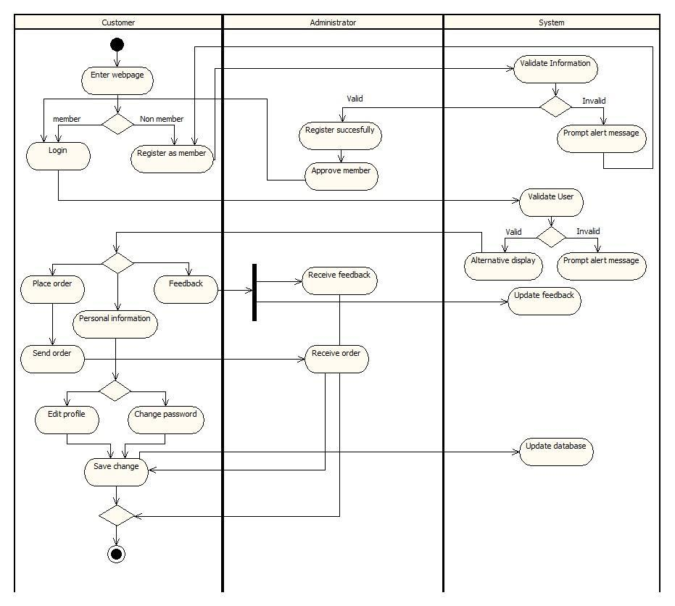

Page | 45
6.2 Inventory System
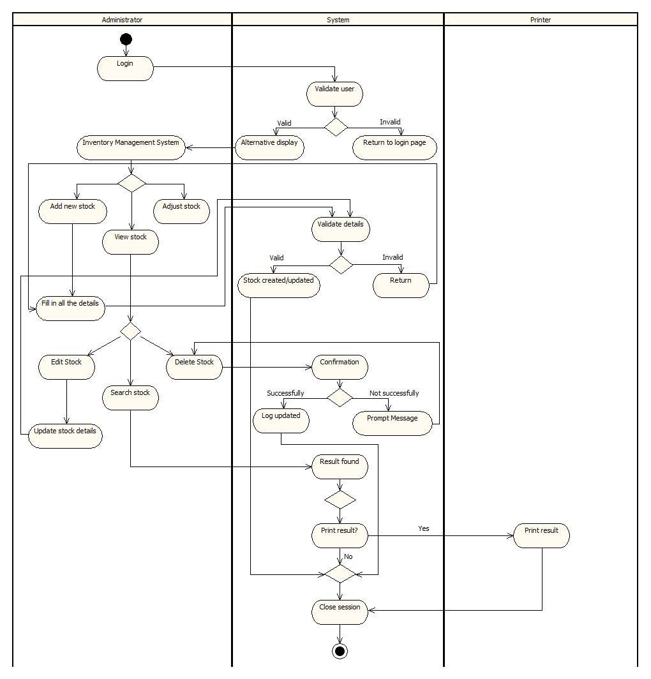

Page | 46
6.3 Payment System

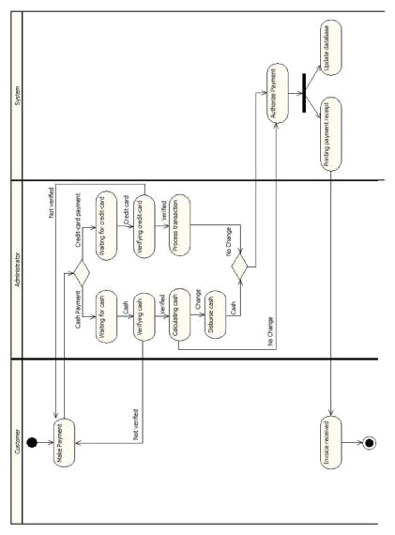

Page | 47
6.4 Report System
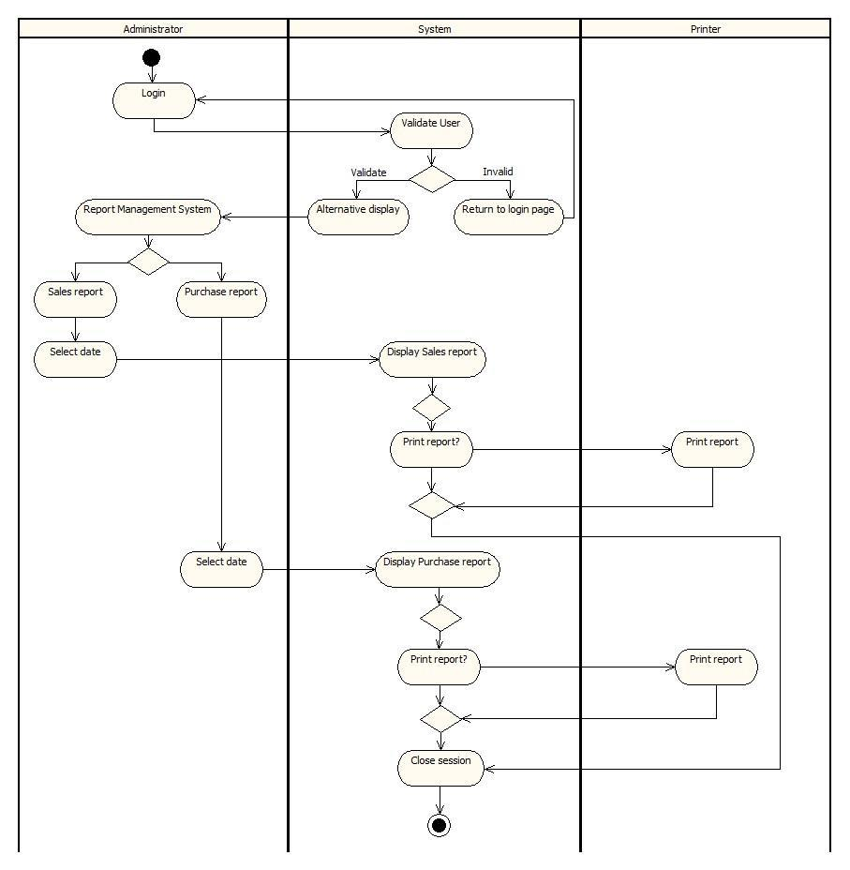

Page | 48
6.5 Purchase order system
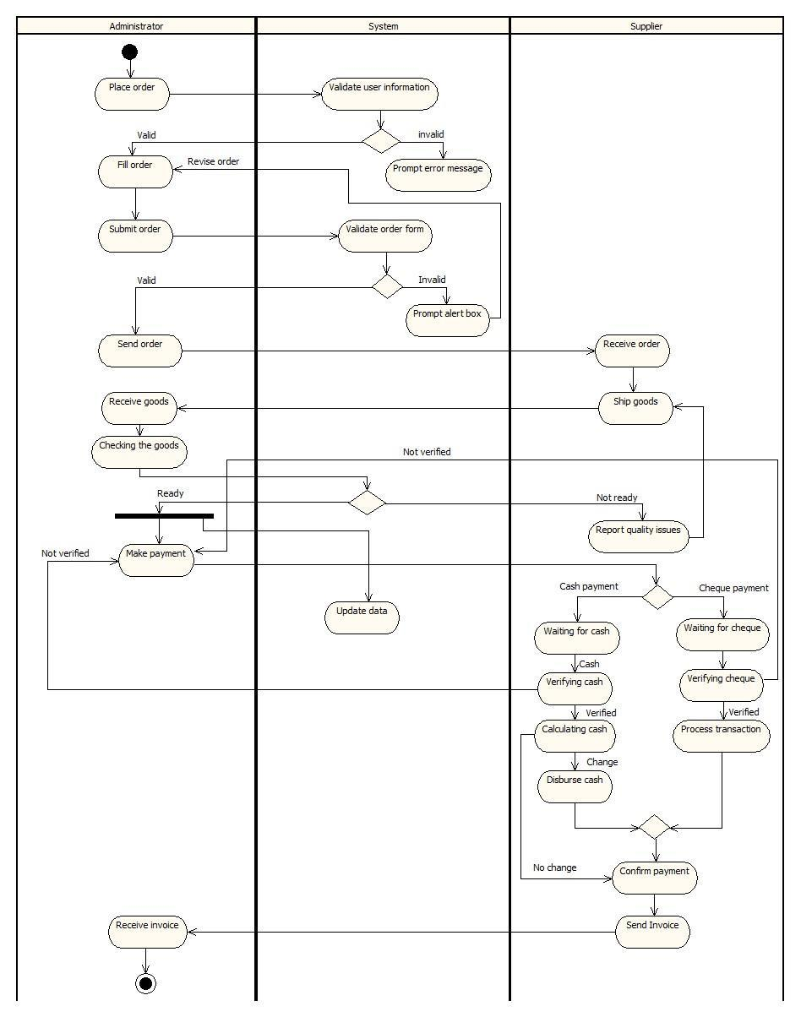

Page | 49
6.6 Sales order system
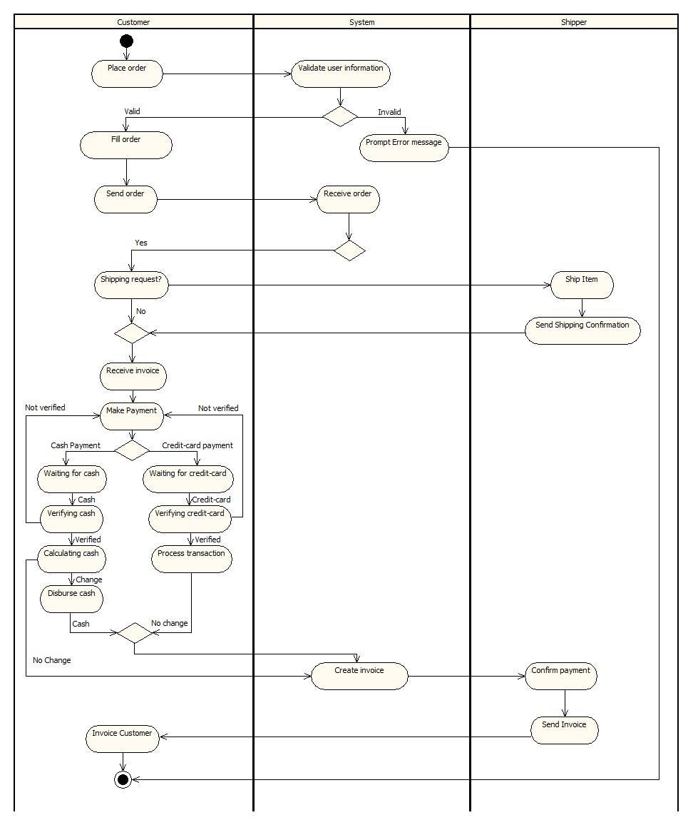

Page | 50
7.0 Sequences diagram

7.1 Customer system

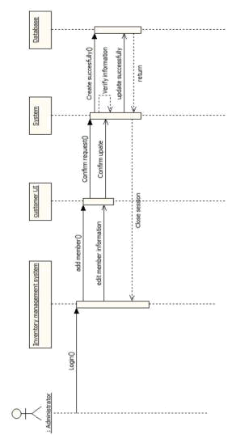

Page | 51
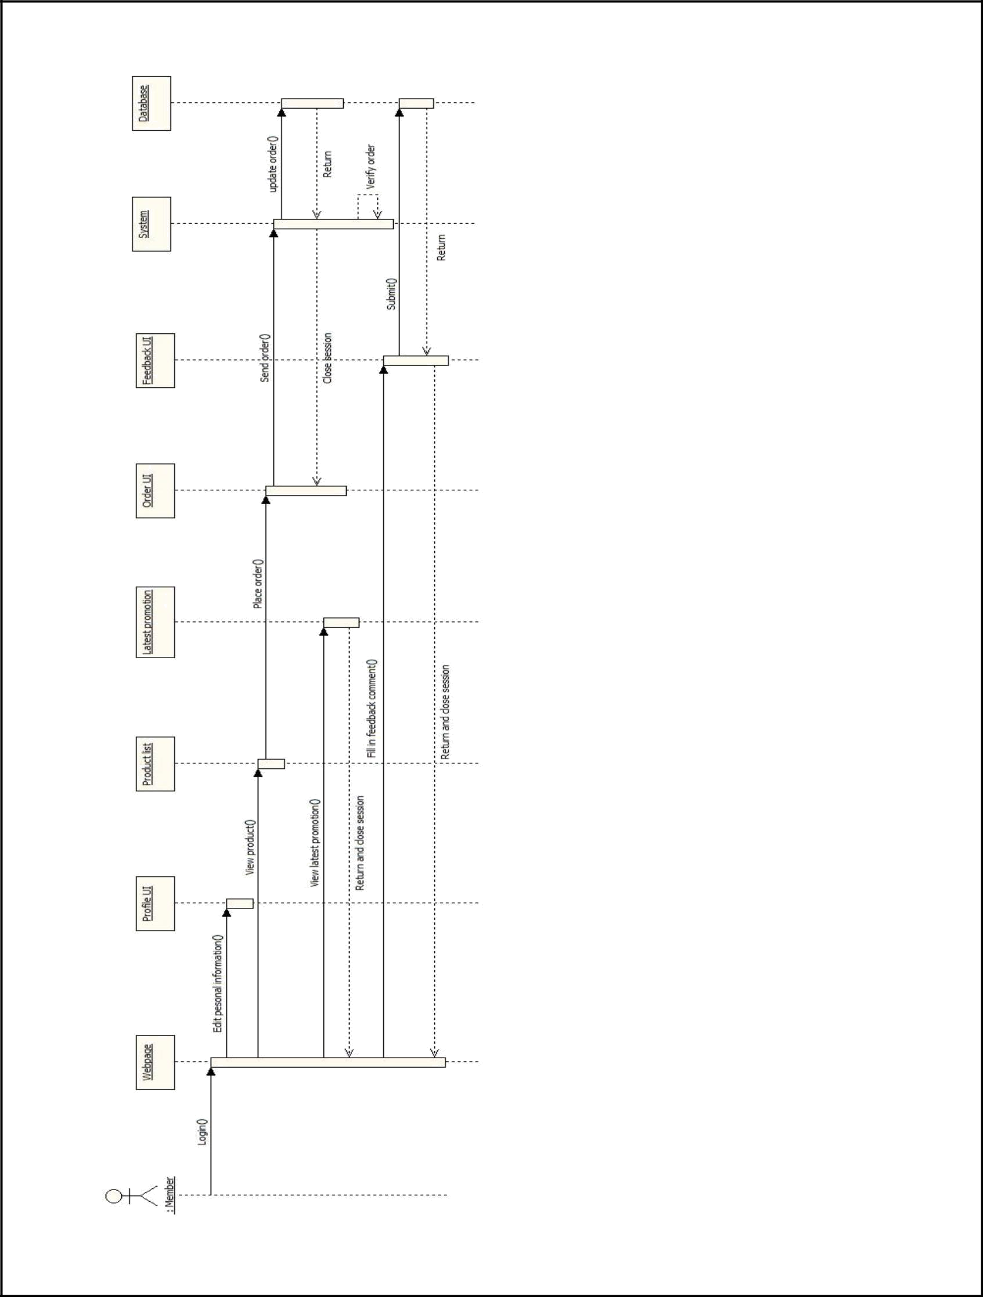

Page | 52
7.2 Inventory System

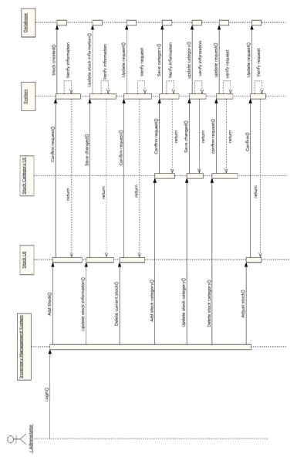

Page | 53
7.3 Payment System

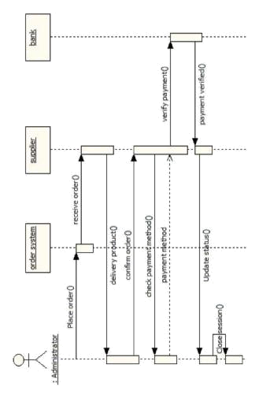

Page | 54
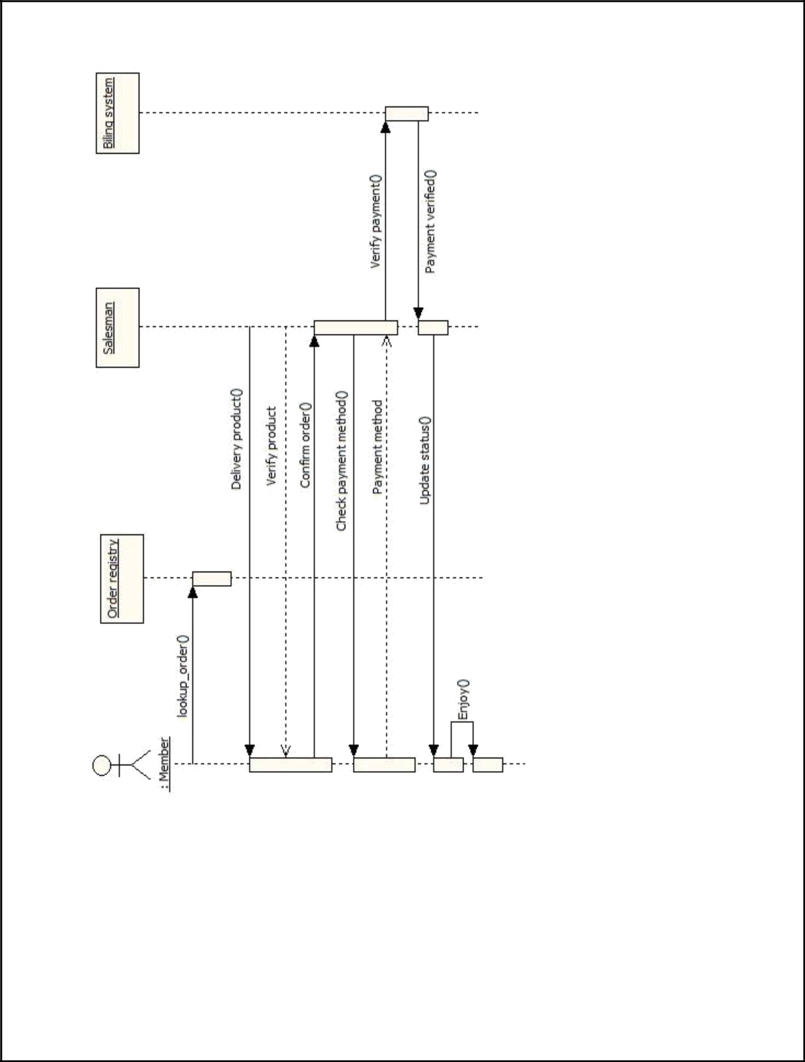

Page | 55
7.4 Report System

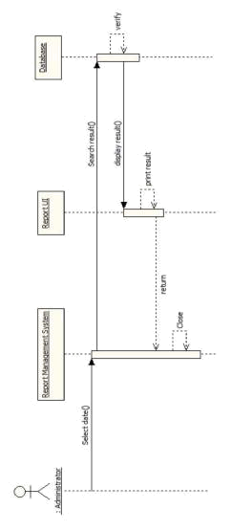

Page | 56
7.5 Purchase order system

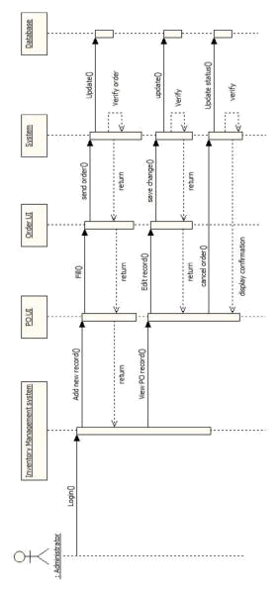

Page | 57
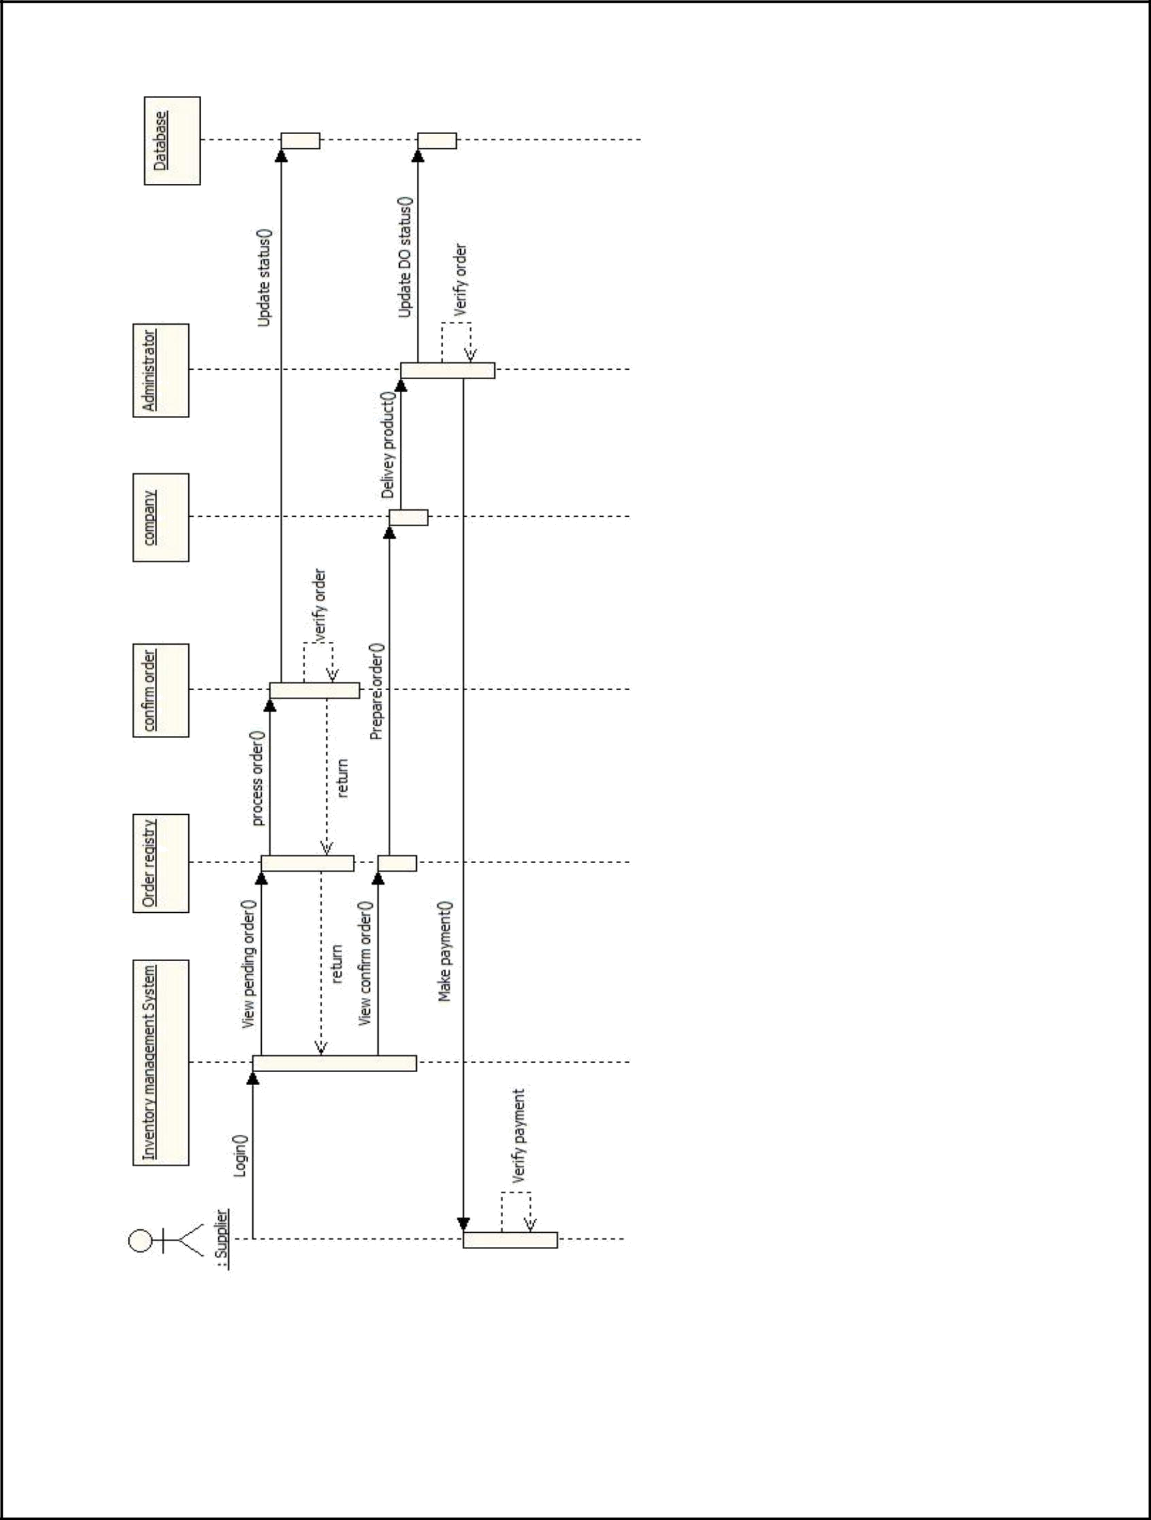

Page | 58
7.6 Sales order system

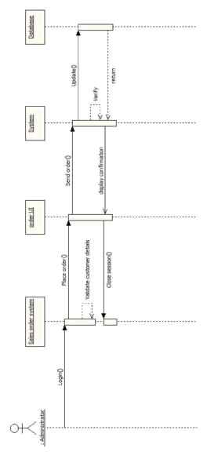

Page | 59
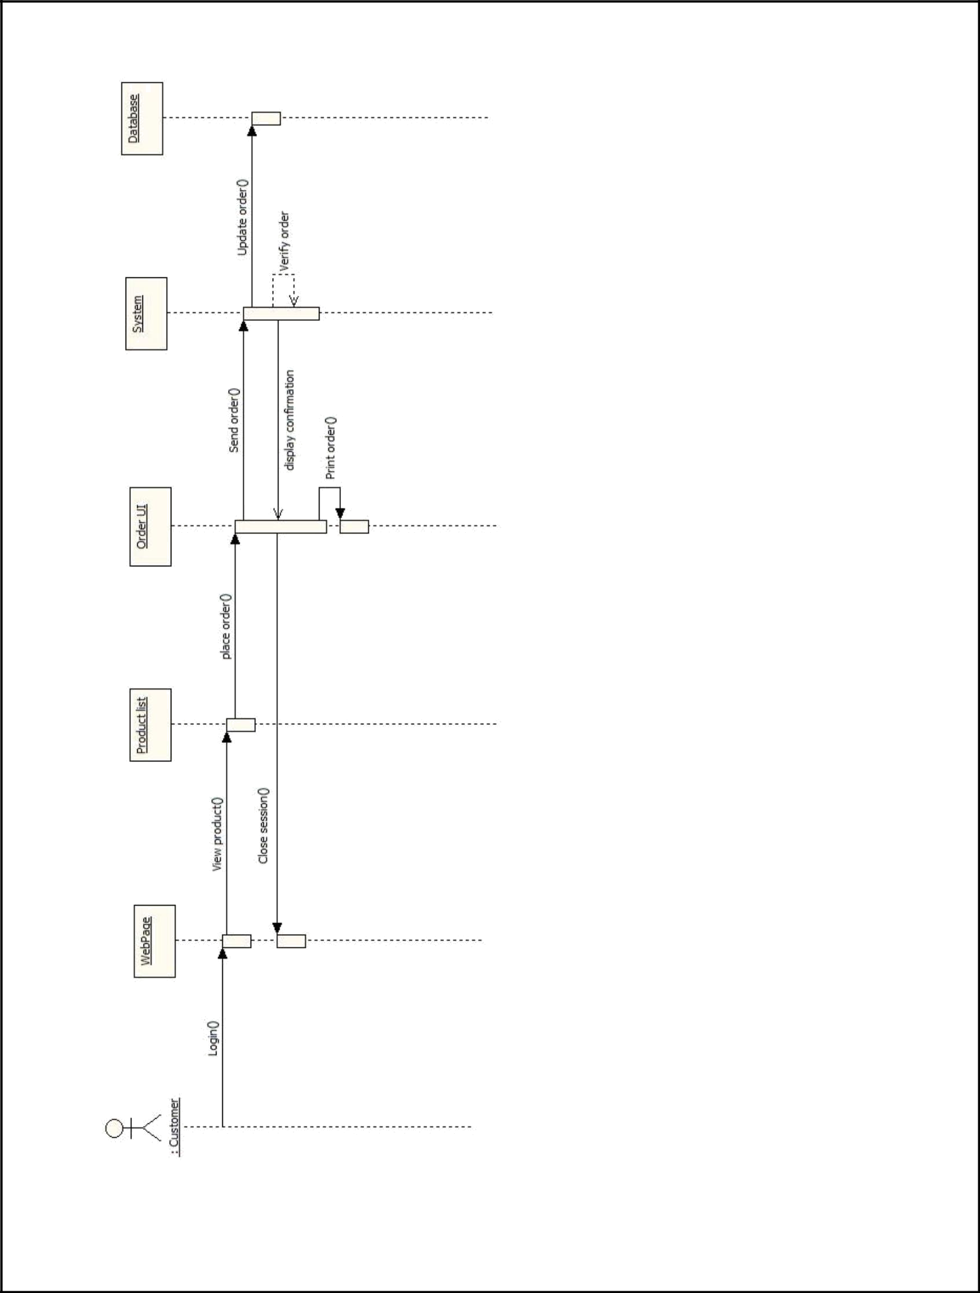

Page | 60
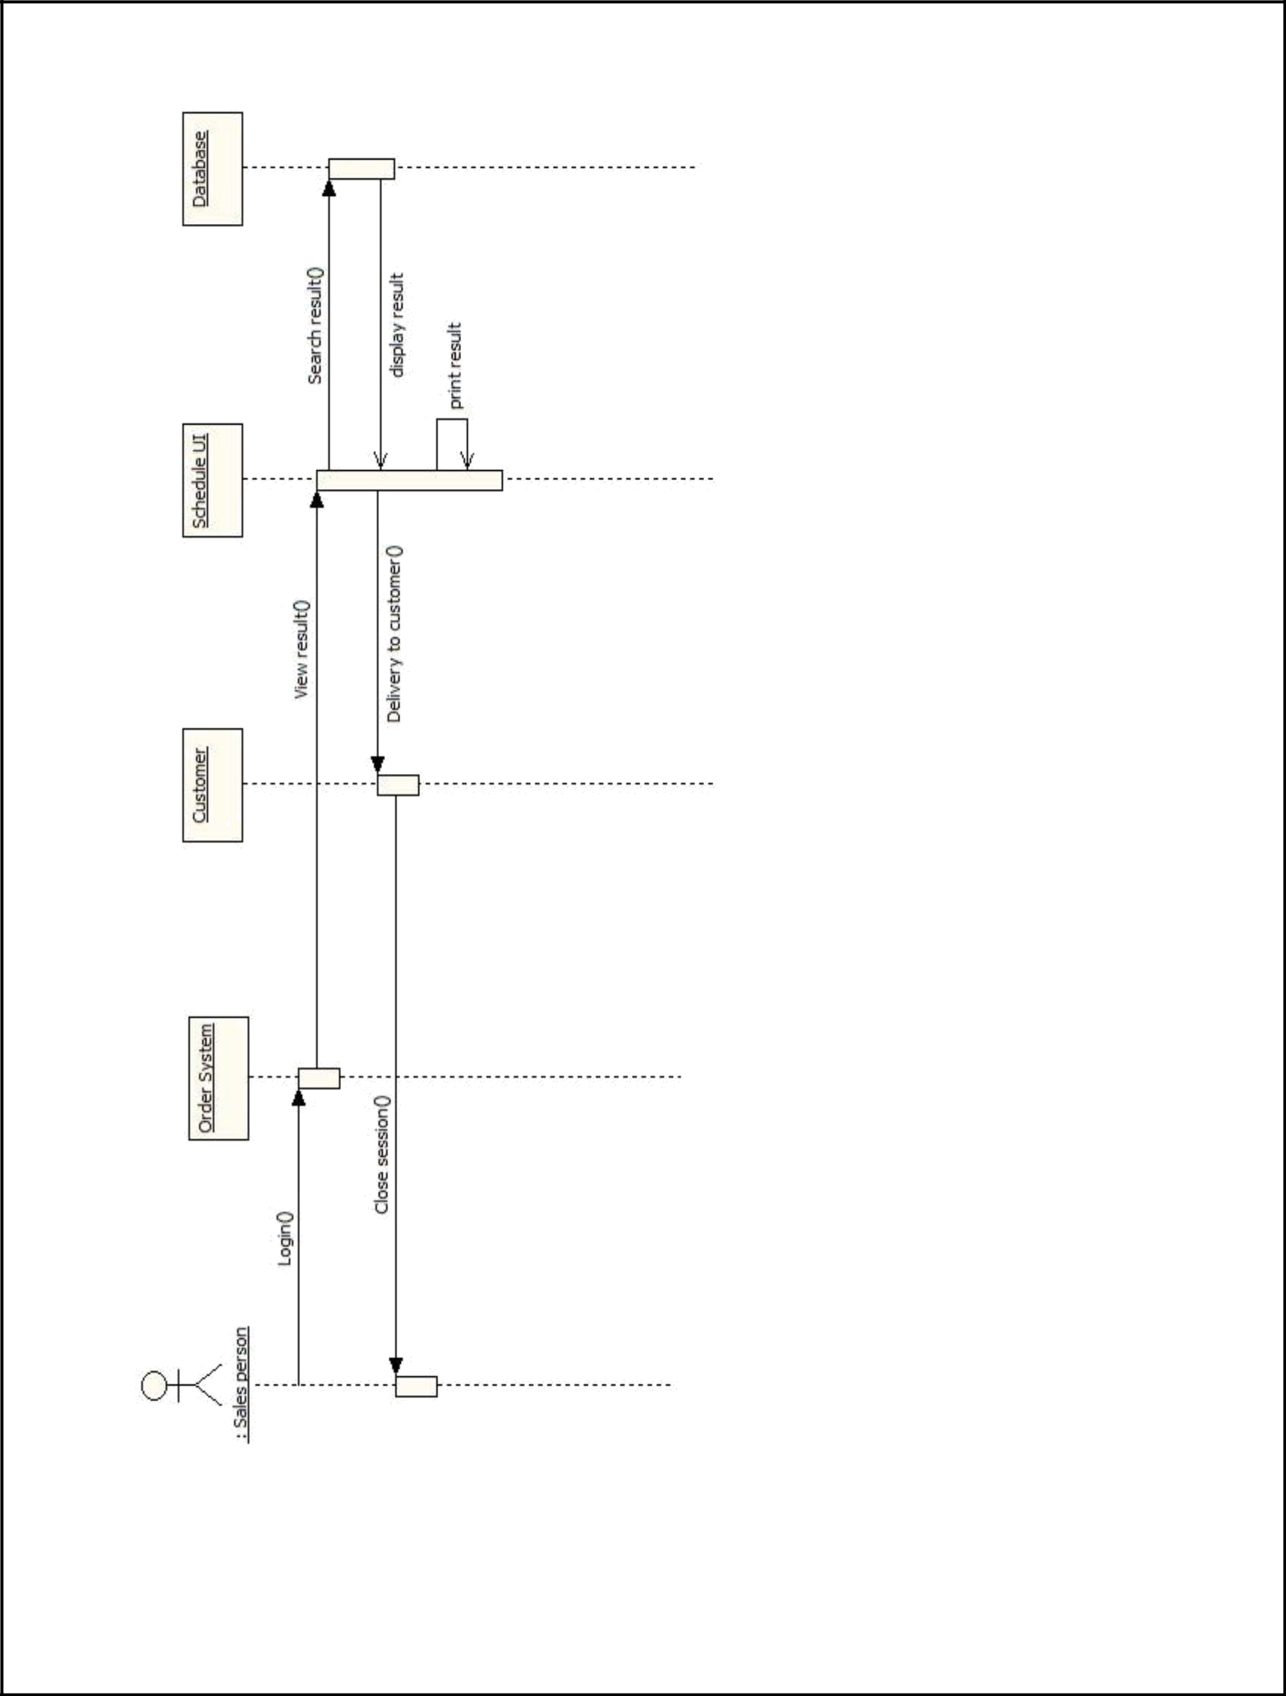

Page | 61

